INVENTORY AND CHECK OUT PREPARED FOR

FLAT 8

29-31 COLVILLE ROAD

LONDON

W11 2BT

7TH JUNE 2018 / 20TH APRIL 2021

**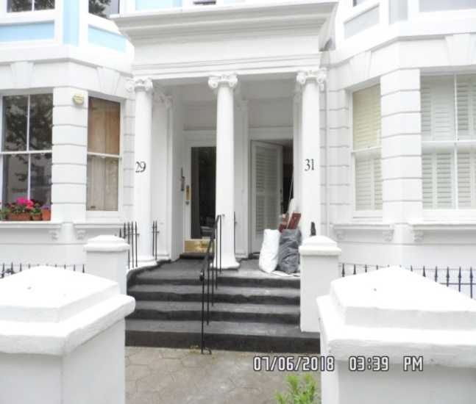**

|  |  |
| --- | --- |
| **CLIENT:** | London Central Portfolio |
| **INSTRUCTED BY:** | Liam Monaghan |
| **JOB NO:** | 1395 |
| **REF:** | MBPS-002 / MBPS-002 |
| **INSPECTED BY:** | Gary Krienkie |
| **PROPERTY SIZE:** | 1 Reception / 2 Bedrooms / 2 Bathrooms / 1 Inner Hallway – Furnished Flat |

‘'WINDY RIDGE' [99 COWLEY HILL, BOREHAMWOOD, HERTS, WD6 5NA](https://maps.google.com/?q=99+COWLEY+HILL,+BOREHAMWOOD,+HERTS,+WD6+5NA&entry=gmail&source=g), TEL: 020 8 386 0950 - MOBILE: 077 67 647 647  
EMAIL: [info@inventorys.net](mailto:info@inventorys.net)<mailto:[info@inventorys.net](mailto:info@inventorys.net)> [www.inventorys.net](http://www.inventorys.net/)  
Registered No: 4263261 VAT No: 822 9322 12



Safety Disclaimer

This inventory report is prepared as an ‘as seen snapshot’ of the property and its contents at the time of the designated inspection and is compiled as a fair and accurate record for the properties internal condition and contents. This does not form any part of a valuation or structural report.

This inventory is compiled on the basis that all items listed are in good order and clean. Any defects or soiling are noted where appropriate. Where inspections are carried out and the tenants’ belongings are in situ, it can be difficult for clerks to differentiate to that belonging to the landlord or tenant. Should the report contain inaccuracies the clerk (Independent Inventories (UK) Ltd ) will not be held responsible.

The clerk preparing the inventory is not an expert in electrical appliances, antiques, furniture style, fabrics, flooring, etc. All descriptions within this report are for identification purposes only in order that each item can be compared to its condition at the commencement of the tenancy.

Lofts and Cellars are not included unless they are converted and safely accessible. Contents will therefore not be noted or checked at checkin or checkout.

Plants and shrubs will not be itemised.

Belongings left by the landlord/agent in a locked room or outbuilding will not be inventoried and are the sole responsibility of the Landlord/agent. Items in garages/sheds such as garden equipment and tools will be inventoried, however tins of paint will not be itemised.

We do not undertake to move heavy items of furniture or access lofts, high-level cupboards, or any other inaccessible places. Contents which have been left in the above-mentioned areas, which have not been inventoried, are the sole responsibility on the landlord. We also do not undertake to open windows, but will confirm whether keys have been seen or not.

Any electrical appliances tested will be for power only and only where practicable. The clerks are not qualified electricians and will only confirm the visual condition of the electrical socket, wiring and or fitting as seen. Boilers, Heating Systems, Gas Fires, Water Supply and Radiators are not tested, and Independent Inventories (UK) Ltd will not take any responsibility for units left either on or off even if on automatic timers. Where smoke alarms and CO Detectors are tested this is for power only and should not be taken to mean that the alarms are in full working order. We only state their presence and cannot state the functioning of this equipment. No responsibility is taken for any damage or malfunction occurring during the testing of such alarms.

The relevant utility companies must check all meter readings, as we cannot be held responsible for any discrepancies. We are not held liable should meters not be located or inaccessible to read. For Health and Safety reasons we do not expect our clerks to access high level areas which involve using ladders/chairs.

The Fire & safety Regulations regarding furnishings, gas, electrical & similar services are ultimately the responsibility of the instructing principle. Where the inventory notes FFR label seen, this should not be interpreted to mean that the item complies with the furniture & furnishings (fire) (safety) (Amendments) 1993. It is a record that the item had a label as described or similar to that detailed in the Guide to the regulations as published by the Department of Trade & Industry, January 1997, (or subsequent edition), attached at the time the inventory was complied.

Blinds in the premises are visually checked. We are unable to verify that the blinds comply with child safety requirements of BS EN 131202009 + A1:2014 placed on the manufacturer, supplier and professional installation of internal window blinds

It is the responsibility of the landlord/managing agent/tenant to agree between themselves the accuracy of the report, and Independent Inventories (UK) Ltd should be notified within 7 days of receipt of the report of any discrepancies within the report.

GENERAL GUIDANCE NOTES

Independent Inventories do not have site of tenancy agreements or other agreements made between the tenant, landlord and management company. As these are guidance notes only it is always advisable that the tenancy agreement is cross referenced. This report will indicate whether in our opinion the tenant is liable for the deterioration or whether it is considered fair wear & tear. Independent Inventories may suggest maintenance, cleaning or tenant’s liability at checkout, but the final responsibility of these suggestions will fall with the landlord or managing agent in respect of the original tenancy agreement. We do not suggest costs of any items, these should be sourced from the relevant contractors by the landlord or managing agent.

CLEANING

We recommend that a professional cleaning company is employed at the end of the tenancy, unless alternative arrangements have been agreed with the Landlord/Managing Agent. Receipts from professional cleaning and carpet cleaning companies must be present to the clerk at the checkout inspection.

If the standard of cleaning is not satisfactory most Landlords/Managing Agents will contract a cleaner and their charges will be charged to the tenant unless otherwise stated in the tenancy agreement.

DECORATION

It is accepted that during the course of the day to day living scuffs will appear on walls and woodwork. However should the marks be found to be excessive charges will be made to you the tenant, unless otherwise stated in the tenancy agreement.

LIGHTING

If the lights are working at checkin then it is normal, if lights are not working at checkout, for these to be the responsibility of the tenant to replace bulbs or to be charged accordingly, unless otherwise stated in the tenancy agreement.

GARDENS/PATIO

If the standard of the garden/patio is found to be untidy compared to the start of the tenancy the Landlord/Managing Agent are entitled to employ a contract gardener and the charge will be made to you the tenant, unless otherwise stated in the tenancy agreement.

MAINTENANCE ISSUES

We recommended should any maintenance issues arise you contact the Landlord/Managing Agent immediately so they can deal with the matter. Should we recommend items require maintenance once a property has been checked out, this is purely stating that an item will require fixing/attention, we are not advising as to whose responsibility this and your tenancy agreement will need to be checked.

CHANGES TO PROPERTY

We recommend that if you wish to make any changes to the décor or remove any of the Landlords belongings you contact the Landlord/Managing Agent for permission and have this confirmed in writing to ensure there are no discrepancies at the end of the tenancy.

TENANTS INFORMATION FOR CHECKING OUT OF PROPERTY

It is important at the checkout that:

1. All cleaning should be completed prior to the checkout appointment as per the tenancy agreement.
2. All personal items must be removed prior to the check out.
3. All items should be in the same location as per the inventory, any stored items should be unpacked and also returned to the same location.
4. If the Inventory clerk has to search for items or you still have belongings in the property to be removed this will result in additional charges being made to the tenant.
5. All beds should be left unmade with the linen folded. Bedding & towels should be cleaned & ironed where relevant.
6. All food items should be removed, freezers defrosted & doors left open & electricity turned off.
7. All light bulbs etc. should all be in working order as at check in.

The property should be left in a clean and tidy condition especially carpets, curtains, windows, upholstery appliances etc. We would suggest that you refer to your tenancy agreement in this matter.

If you are not ready to leave it may not be possible to carry out the checkout. In this case a return visit will be necessary resulting in a cancellation charge.

All keys to the property must be handed over at the time of checking out to the Inventory clerk or alternatively to the agents prior to the check out taking place.

The Inventory Clerk acts as an independent and reasonable body and will avoid unnecessary criticism or derogatory comments when compiling or checking the Inventory.

At the termination of the tenancy the inventory will be checked and any obvious or significant discrepancies will be reported to the Managing Agent/Instructing Principal. This report will indicate whether in our opinion the tenant is liable for the deterioration or whether it is considered fair wear & tear. Normal fair wear and tear will be assessed on the lengthy of the tenancy and type occupancy.

INDEX

PAGE

|  |  |
| --- | --- |
| UTILITY READING | 1 |
|  |  |
| KEYS | 3 |
|  |  |
| GENERAL SUMMARY AT CHECKIN | 4 |
|  |  |
| INSTRUCTION MANUALS | 5 |
|  |  |
| ENTRANCE AND RECEPTION | 6-14 |
|  |  |
| KITCHEN AREA | 15-22 |
|  |  |
| REAR HALLWAY | 23-27 |
|  |  |
| BEDROOM 1 | 28-35 |
|  |  |
| EN-SUITE BATHROOM | 36-41 |
|  |  |
| BEDROOM 2 | 42-47 |
|  |  |
| BATHROOM | 48-53 |
|  |  |
| DECLARATION AT CHECK IN | 54 |
|  |  |
| ADDITIONAL AMENDMENTS | 55 |
|  |  |
| SIGNED SCHEDULE OF CONDITION AT CHECK IN | 56-58 |
|  |  |

**UTILITY READINGS / KEY LIST& INSTRUCTION MANUALS**

|  |  |  |
| --- | --- | --- |
| **ELECTRIC** | **GAS** | **WATER** |
| METER NUMBER:  S72A19068 | METER NUMBER:  K0510612 DG | METER NUMBER:  N/A |
| READING:  69226.73 | READING:  33954.28 | READING:  N/A |
| LOCATION:  Communal hallway cupboard | LOCATION:  Front exterior | LOCATION:  Not located |

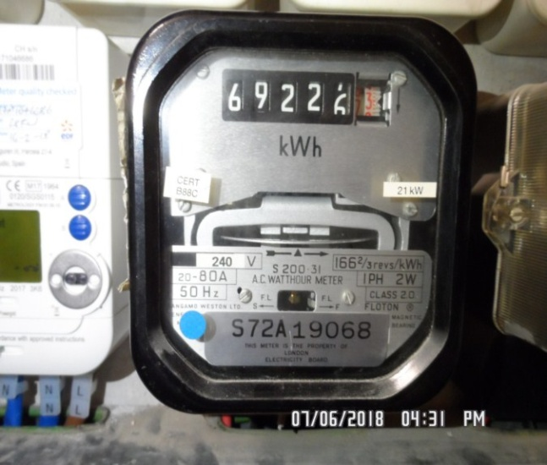 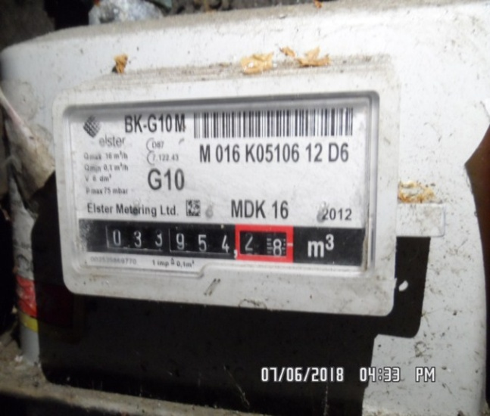

|  |  |  |
| --- | --- | --- |
| **ELECTRIC** | **GAS** | **WATER** |
| METER NUMBER:  S72A19068 | METER NUMBER: | METER NUMBER:  N/A |
| READING:  74374.37 | READING: | READING:  N/A |
| LOCATION:  Communal hallway cupboard | LOCATION:  Front exterior cupboard  LOCK AT CHECK OUT\*\*\* | LOCATION:  Not located |

|  |
| --- |
| **LOCATION OF:** |

|  |  |  |
| --- | --- | --- |
| **STOP COCK** | Unknown | |
| **FUSE BOARD** | Hallway cupboard | |
| **ALARM PANEL**  **This has not been tested** | Unknown | MAKE: |

|  |
| --- |
| **FIRE SAFETY** |

|  |  |
| --- | --- |
| **SMOKE ALARM** | Mains powered and Power light on  Tested with Canned smoke and working order |
| **CARBON MONOXIDE ALARM** | N/A |

|  |  |  |
| --- | --- | --- |
| **KEYS AT CHECKIN** | **KEYS AT CHECKOUT** | |
| **KEY TYPE / SERIAL NUMBER / QTY** | **KEY TYPE / SERIAL NUMBER / QTY** |
| 2 x Silver Banham (85D10950) |  |
|  |  |
|  |  |
|  |  |
|  |  |
|  |  |
| **KEYS RECEIVED BY: Posted through letterbox**  **\\Pc-1\mbps\II\8TH JUNE\flat 8, 29-31 colville rd - in\Pictures\New folder\SAM_9203 (Copy).JPG** | **KEYS RETURNED TO: Picked up and dropped off at LCP, picture of keys taken \*\*\*** | |

|  |
| --- |
| **GENERAL SUMMARY** |

|  |  |  |
| --- | --- | --- |
| **ITEM** | **CHECKIN NOTES** | **CHECKOUT NOTES** |

|  |  |  |  |
| --- | --- | --- | --- |
| **GENERAL CONDITION** | | Professionally cleaned for start of tenancy  Further general cleaning required | A full professional clean is required |
| **ODOUR** | | N/A | N/A |
| **DECORATIVE ORDER / WOODWORK** | | Good order  Defects as noted  Woodwork scuffed/ chipped | Defects as noted  Dusty  Woodwork scuffed/ chipped |
| **FLOORING** | | Good order  Defects as noted  Requires further cleaning | Defects noted  Cleaning required |
| **CURTAINS / BLINDS** | | Good order | Defects noted  Cleaning required |
| **BLIND REGULATIONS** | | N/A |  |
| **UPHOLSTERY** | | Vacuumed in situ for the start of tenancy  Good order | Defects noted |
| **FFR LABELS** | FFR labels not seen | |  |
| **LINEN** | In use  Freshly laundered | | In use  Requires further cleaning |
| **LIGHTS** | Bulbs missing / not working | | Bulbs missing / not working |
| **KITCHEN / APPLIANCES** | All clean order  All appliances power tested  Fridge/ freezer left shut power on | | All appliances power tested  Fridge/ freezer left shut power on  Requires further cleaning |
| **BATHROOMS/**  **WC** | All fitments free of lime scale  Water outlets tested and working  Requires further cleaning | | Water outlets tested and working  Requires further cleaning |
| **WINDOWS** | Fitments complete  Clean to interior  Requires further cleaning | | Fitments complete  Requires further cleaning |
| **GARDEN /**  **TERRACE** | N/A | | N/A |

|  |  |
| --- | --- |
| **MANUALS SUPPLIED AT**  **CHECKIN** | **MANUALS RETURNED AT**  **CHECKOUT** |
| **APPLIANCE / MAKE** | **APPLIANCE/MAKE** |
|  |  |
|  |  |
|  |  |
|  |  |
|  |  |

 \*N.B – Heavy items will not be moved or inspected behind/under, for health & safety reasons. We will not be held liable should any damages/stains/marks be found during the tenancy in these areas. Should the occupant find any of the above they should, inform the landlord/agent immediately and if/where possible take photographic evidence and pass to the relevant parties.

 This camera symbol throughout the Inventory check in/out indicates where a photo has been taken. Photos can be found at the back of each room in the report with the relevant headings

**ENTRANCE AND RECEPTION**

|  |  |  |  |
| --- | --- | --- | --- |
| **Door** | Exterior Door Frame  Wood painted cream | 1. Grubby throughout 2. Painted over defects throughout |  |
|  | Exterior Door  White wood single glazed glass pane with brushed fittings including  Numeral ”8”  2 x Yale lock and handle  Letter box  Draught excluder | 1. All brass fittings tarnished 2. Door grubby and lightly scuffed throughout 3. Chipping to edges 4. Shading and discolouration around the edges of the frame throughout |  |
|  | Interior Door Frame  Wood painted cream |  |  |
|  | Interior Door  White wood with grey Yale latch and brass twist lock  White wood twin panel shutter | 1. Filler marks around the Yale lock 2. Light scuff marks |  |

**ENTRANCE AND RECEPTION**

|  |  |  |  |
| --- | --- | --- | --- |
| **Walls** | Plaster painted pale yellow and white | 1. Small number of light rub marks mid to low level scattered throughout 2. 2 x Filled drill holes to right hand side wall above TV 3. 2 x Pin holes to entrance wall right of window eye level 4. Right hand side wall underneath window sill some light shading seen |  |
| **Ceiling** | Plaster painted white  White plastic smoke detector | 1. Tested and working 2. Some light finger soil marks around recessed spotlights 3. Some light scuffing seen forward of entrance door |  |
| **Lights** | 8 x White metal spotlights | 1 x bulb not working |  |
| **Woodwork** | Skirting painted white | 1. Dusty to top edge beneath window 2. Some light very minor rub marks seen |  |

**ENTRANCE AND RECEPTION**

|  |  |  |  |
| --- | --- | --- | --- |
| **Switches and sockets** | Assortment of switches and sockets in black plastic and chrome |  |  |
| **Flooring** | Light wood effect laminate | 1. Grey circular discoloured patch right of entry 2. Heavy scratching and tarnishing to the varnish underneath dining table sections 3. Further light scratches seen throughout |  |
| **Heating** | 2 x White metal radiators each with thermostatic valve  Valve cap present |  |  |
| **Windows** | 3 x White wood framed single glazed sliding sash windows each has chrome fittings  White metal security clasps to right hand side window | 1. Light dust to window exterior 2. Light cracking to paintwork of frames 3. Window to the far left hand side 2 x hairline cracks to the opening panel at high level to both left and right hand side corners 4. 2 x hairline cracks seen 5. White scratching to all window panels |  |

**ENTRANCE AND RECEPTION**

|  |  |  |  |
| --- | --- | --- | --- |
| **Shutters** | 8 x White wood twin panel shutters | 1. Right hand side some scuffing to the exterior unit |  |
| **Miscellaneous** | White plastic Videx entry phone  White plastic Horstmann thermostat control |  |  |
| **Picture** | Photograph of cafe printed on wood in black wooden frame | 1. Small number of minor chips to frame |  |
| **Television** | Flat screen Samsung black with remote control |  |  |
| **Doormats** | 2 x Dark grey doormats with black rubber edges | 1. In used order |  |
| **Doorstop** | Chrome with black rubber tip | 1. Intact |  |

**ENTRANCE AND RECEPTION**

|  |  |  |  |
| --- | --- | --- | --- |
| **Crockery** | Matching set in off white ceramic comprising each with 4 x Bowls, side plates and plates  2 x White mugs  1 x White fruit bowl | 1. Mug seen in kitchen 2. Fruit bowl seen in kitchen |  |
| **Glass ware** | 4 x Wine glasses  Bottles style vase with narrow neck containing plastic plants | 1. Seen in kitchen |  |
| **Vase** | Black gloss with plastic sunflowers |  |  |
| **Cushions** | 1 x Black large fray  1 x Pale grey large with yellow and beige triangle patterned  Further 2 x blue, black and green with yellow zigzag pattern scatter cushions  1 x light brown cushion | 1. Several work spot stains to one side |  |
| **Waste bin** | Black and chrome pedal style | 1. Pedal is currently not working |  |

**ENTRANCE AND RECEPTION**

|  |  |  |  |
| --- | --- | --- | --- |
| **Dining table** | White lacquered wood circular table top  Light wood legs | 1. Light scratches seen to the top surface throughout |  |
| **Dining chairs** | 4 x Moulded plastic 2 x Black  2 x Yellow with light wood legs | 1. Some light scuffing to the chairs in places |  |
| **Side table** | White moulded plastic with hexagonal table top | 1. Appears to be intact and in good order |  |
| **Sofa** | Pale grey fabric 3 Seater with chrome legs  2 x Matching throw cushions  Matching footstool | 1. Fire labels not seen 2. Appears to be intact and in good order |  |
| **TV cabinet** | Light wood in 4 x Light wood sliding doors opening insitu  Each cabinet compartment containing 1 x Shelf | 1. Shelf not mounted to right hand side cabinet compartment |  |

**ENTRANCE AND RECEPTION**

|  |  |  |  |
| --- | --- | --- | --- |
| **Coffee table** | Black plastic and medium wood | 1. 2 x Adhesive marks and various smudges and light scratches to plastic part of table top |  |
| **Coat and hat stand** | Black metal floor standing | 1. Appears to be intact and in good order |  |

Exterior door Exterior door

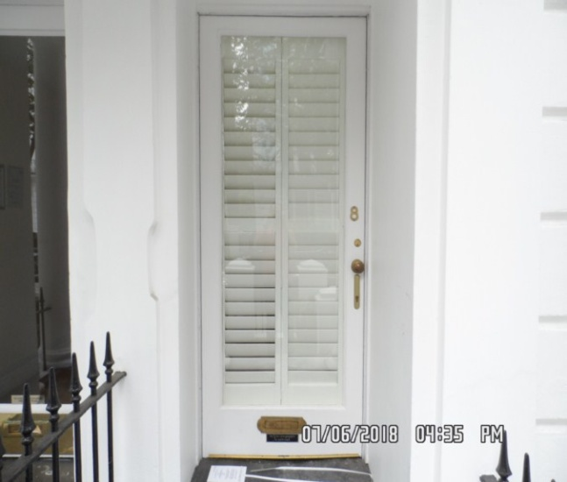 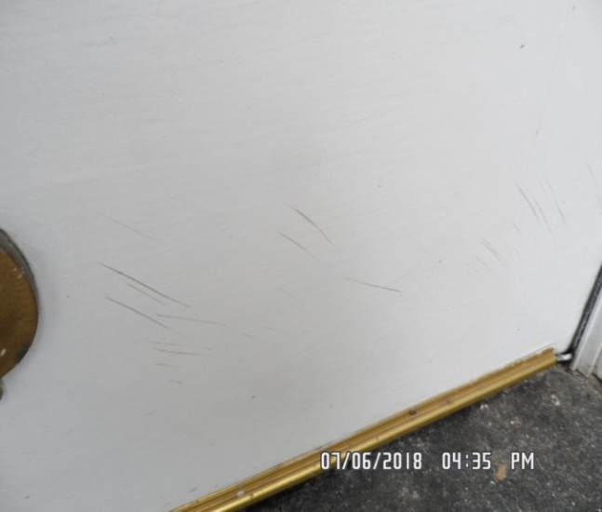

Reception Reception

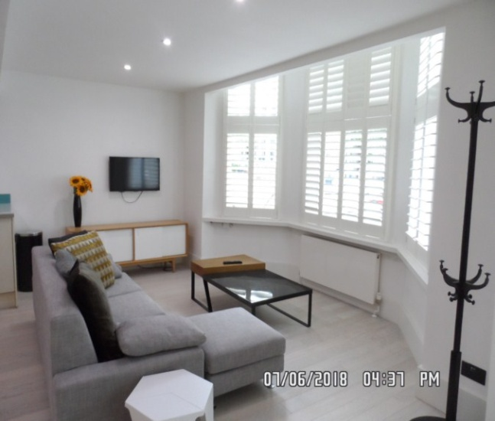 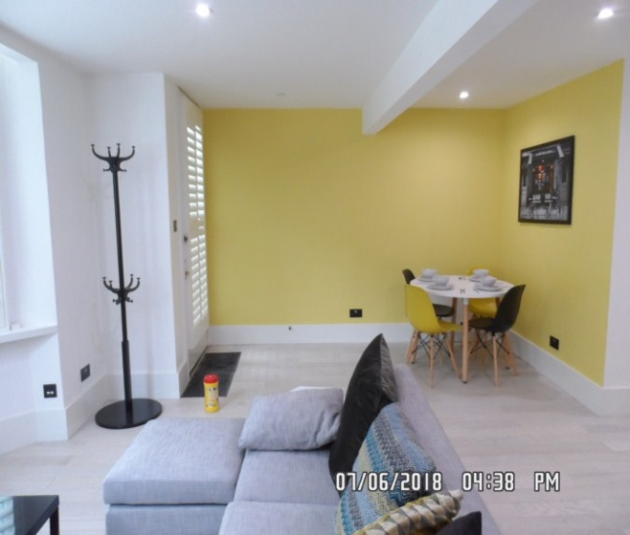

Reception Flooring

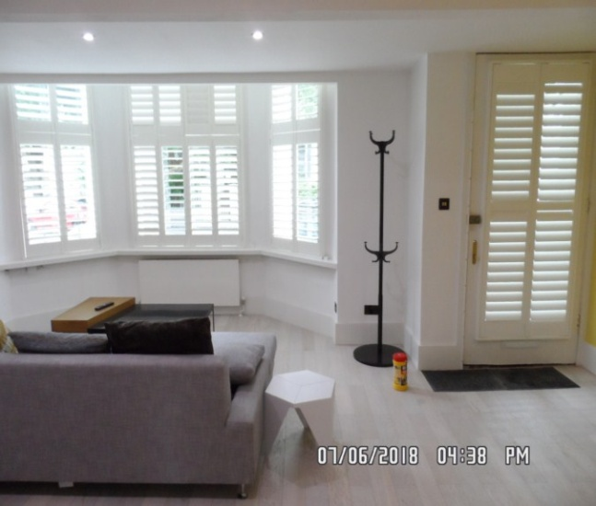 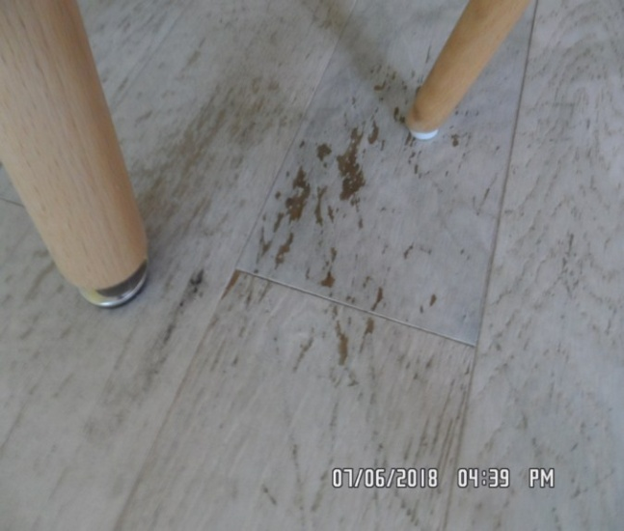

Walls Coffee table

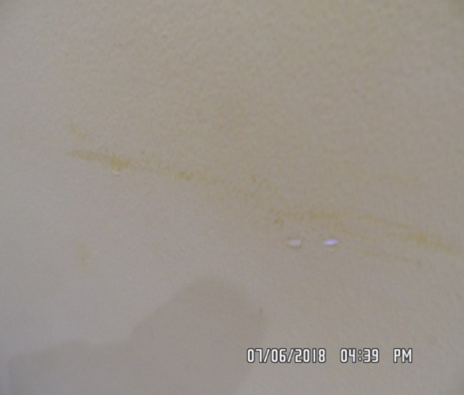 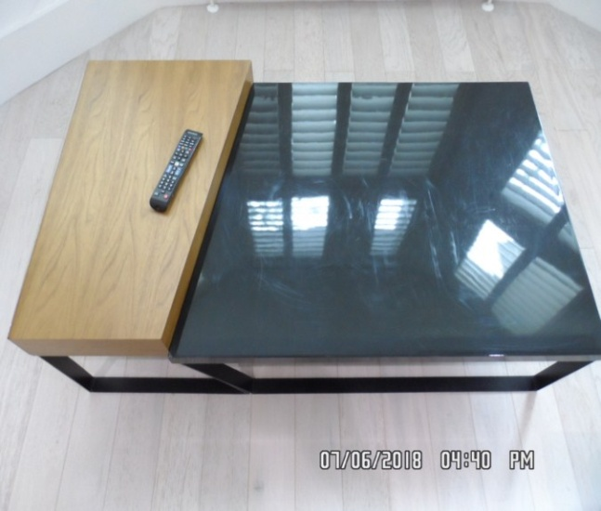

Window Window

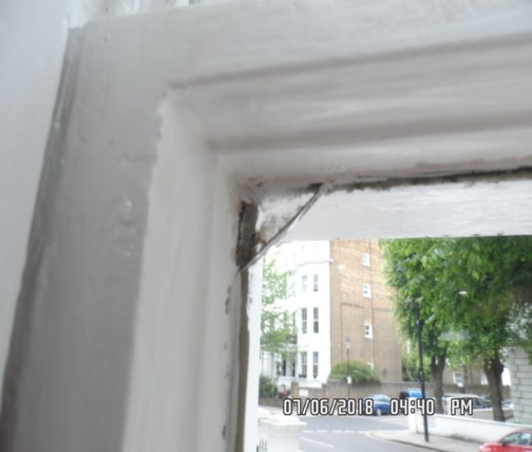 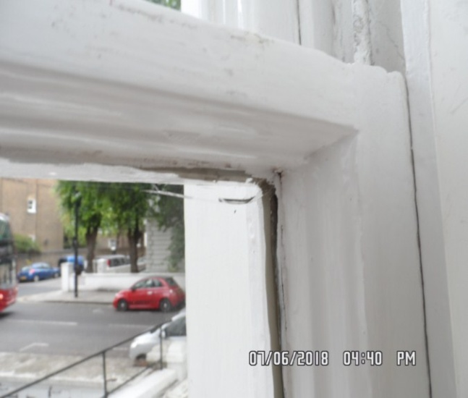

Window Interior door

**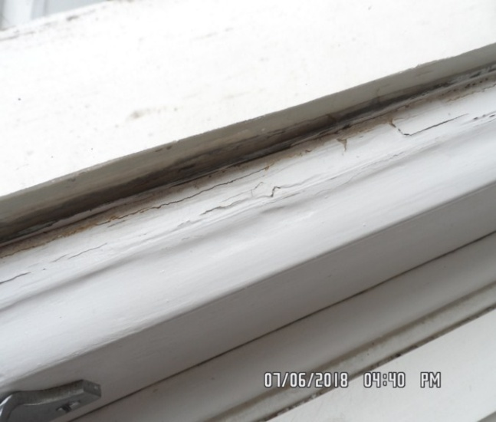 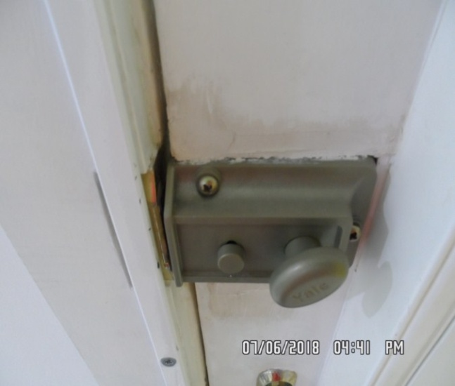**

**KITCHEN AREA**

|  |  |  |  |
| --- | --- | --- | --- |
| **Walls** | White plaster with blue tinted glass splashback panes | 1. Some light splash marks above wall to the rear of the sink 2. Further light splashes seen above the stand up throughout |  |
| **Ceiling** | Continuation of reception | 1. Appears to be intact and in good order 2. Above kitchen units to the far right hand side some water damage or water staining seen |  |
| **Switches and sockets** | Assortment of black plastic and chrome switches and sockets | 1. All appear to be intact |  |
| **Flooring** | Light wooden laminate continuation from reception | 1. Scattered scratches seen to the top surface |  |
| **Unit Description - Units are inspected from left to right** | Beige lacquered wood with chrome handles |  |  |
| **Wall unit 1** | 1 x Single cupboard with 2 x Shelves |  |  |

**KITCHEN**

|  |  |  |  |
| --- | --- | --- | --- |
| **Wall unit 2** | Single cupboard with 2 x Shelves |  |  |
| **Wall unit 3** | Single cupboard with 2 x Shelves |  |  |
| **Wall unit 4** | Single cupboard with 3 x Shelves |  |  |
| **Floor units (inspected from left to right)** |  |  |  |
| **Floor unit 1** | Single cupboard with 1 x Shelf  1 x Drawer |  |  |
| **Floor unit 2** | Single cupboard with 1 x Shelf  1 x Drawer |  |  |
| **Floor unit 3** | Corner cupboard containing rotating silver rack |  |  |

**KITCHEN**

|  |  |  |  |
| --- | --- | --- | --- |
| **Floor unit 4** | Single cupboard | 1. Peeling to the laminate at high and low level to exterior door |  |
| **Work surface** | White plastic | 1. Small chip right of hob   1. Some light debris to the top surface – could benefit from final clean |  |
| **Sink** | Stainless steel with chrome shower head top mixer tap  Half sink and 2 x Silver strainer plug | 1. Could benefit from final wipe to interior |  |
| **Extractor hood** | Silver metal unbranded includes concealing door to matching unit | 1. Light and fan tested and working |  |
| **Hob** | Schott Ceran black glass includes 4 x Ceramic burners | 1. Minor heat damage to glass 2. Tested for power |  |

**KITCHEN**

|  |  |  |  |
| --- | --- | --- | --- |
| **Oven** | Culina black metal double oven contains chrome shelf  Grill pan with chrome insert  Low level contains chrome shelf | 1. Serial number not seen 2. Appears new |  |
| **Fridge** | Lamona integrated white includes concealing doors to match kitchen units  4 x Glass shelves  2 x Salad crisper  3 x White door compartments  Freezer contains 4 x Compartments  Serial number – 1490106302 | 1. Clean to interior 2. Tested for power |  |
| **Dishwasher** | Integrated Lamona includes concealing door to match units  2 x Rack shelves  1 x Cutlery basket  Serial number – 1380002211 | 1. Tested for power 2. Clean to interior |  |

**KITCHEN**

|  |  |  |  |
| --- | --- | --- | --- |
| **Crockery** | 4 x White ceramic mugs |  |  |
| **Utensils** | Matching set stainless steel with red rubber handles comprising potato masher  Ladle  Fish slice  Slotted spoon  Serving spoon  Stainless steel stand |  |  |
| **Knife block** | Brushed metal and light wood includes 5 x Knives | 1. All knives appear to be in good used order |  |

Kitchen Sink

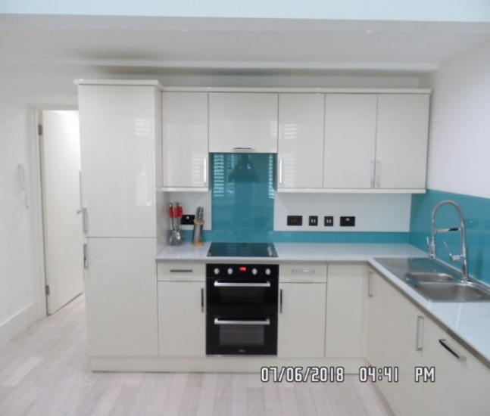 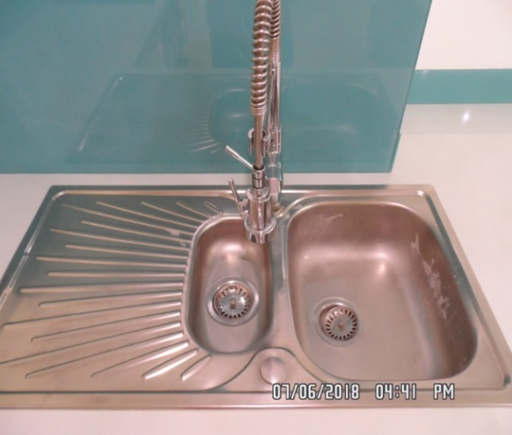

Sink Dishwasher

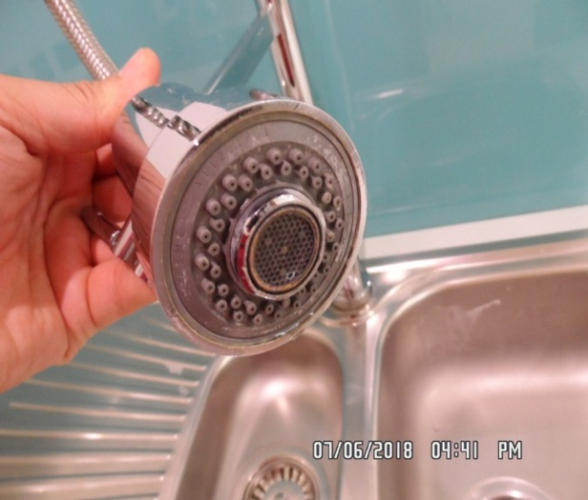 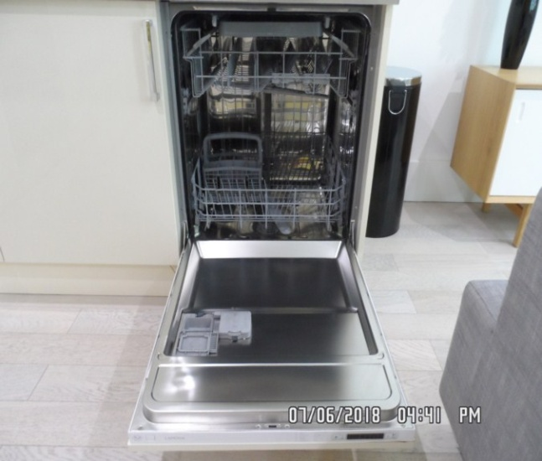

Heater alarm Fridge/ freezer

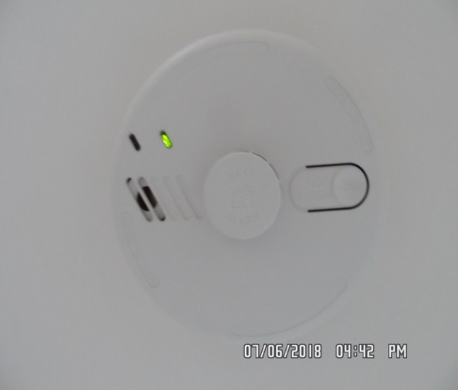 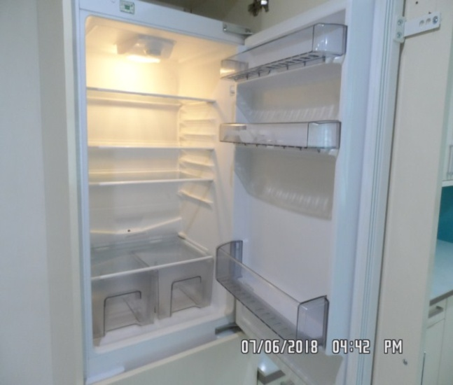

Fridge/ freezer Extractor

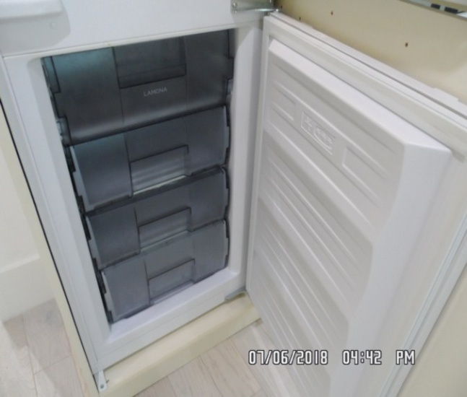 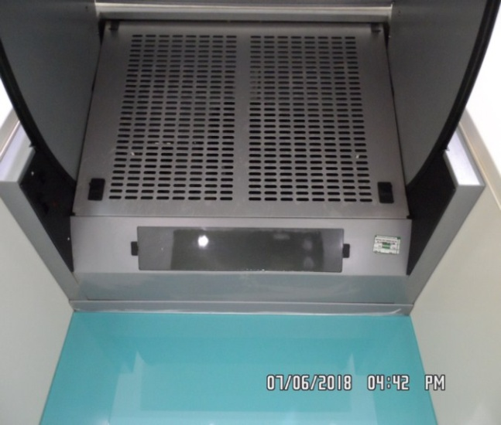

Hob Oven

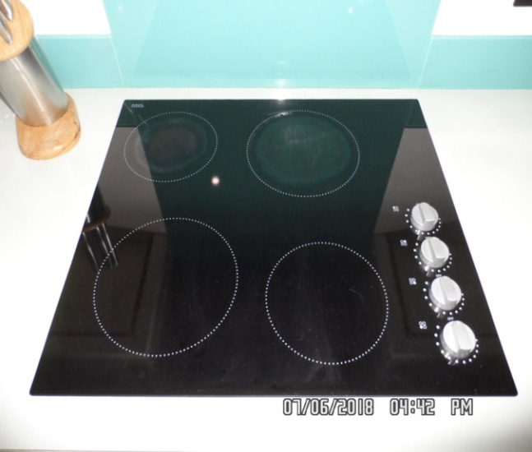 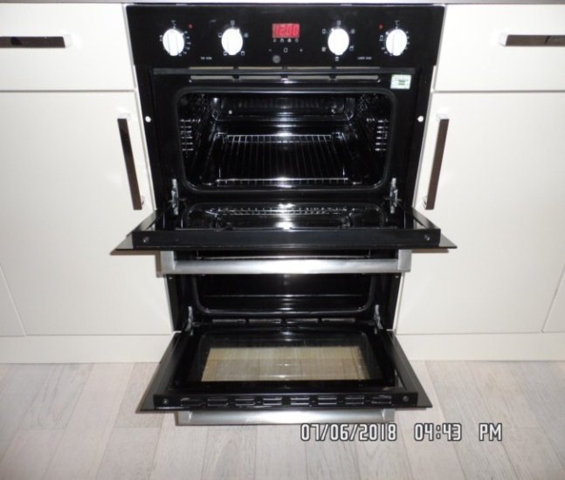

Kitchen units Ceiling

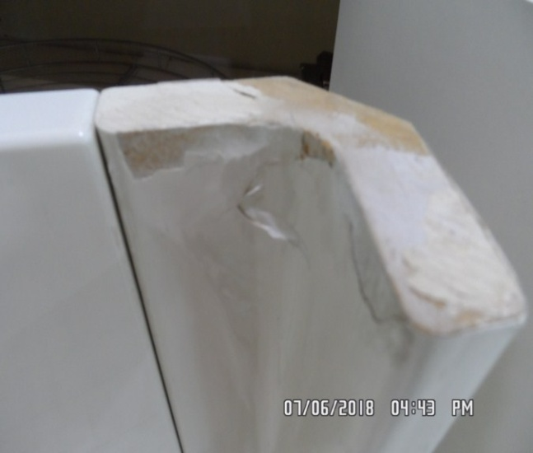 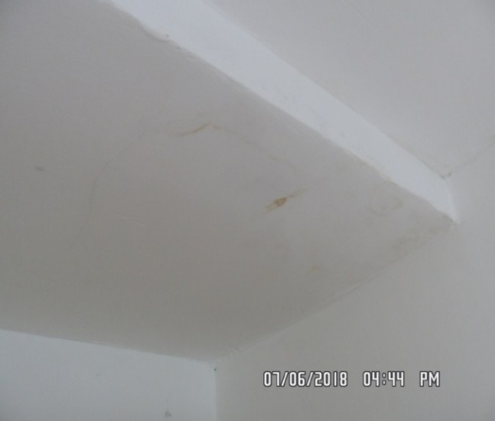

Walls Flooring

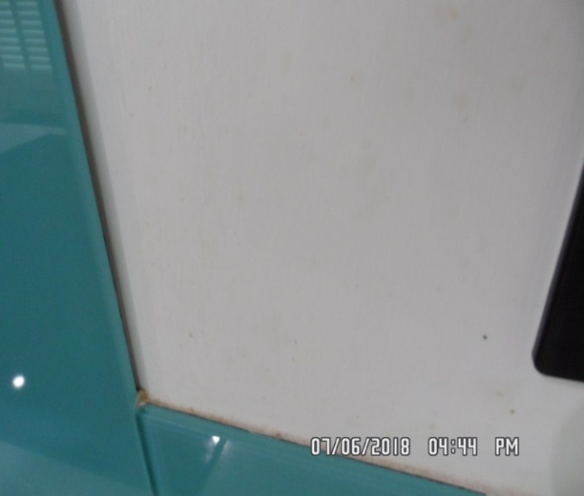 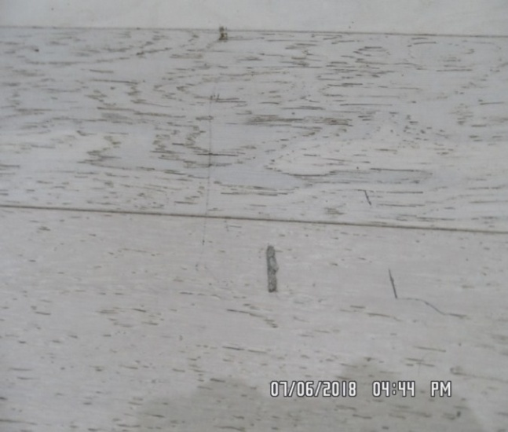

Kitchen unit

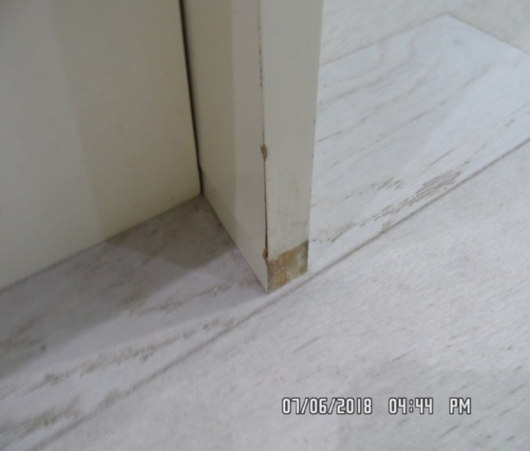

**REAR HALLWAY**

|  |  |  |  |
| --- | --- | --- | --- |
| **Door** | Exterior Door Frame  White wood | 1. Slight hairline cracking seen along the edges of the frame |  |
|  | Exterior Door  White wood with brushed metal handle | 1. Some light very minor scuffing seen at mid and low level |  |
|  | Interior Door Frame |  |  |
|  | Interior Door  White wood with brushed metal handle |  |  |
| **Walls** | White plaster | 1. Slight patchy appearance above rear light switch to left wall 2. Small chip to left wall above rear built in cupboard 3. Minor smudge staining to left wall behind shelves |  |

**REAR HALLWAY**

|  |  |  |  |
| --- | --- | --- | --- |
| **Ceiling** | White plaster  White smoke detector | 1. Tested and working 2. Appears to be intact and in good order |  |
| **Lights** | 2 x White metal spotlights | 1. Tested and working |  |
| **Woodwork** | Skirting painted cream | 1. Appears to have 1 or 2 x light scuff marks 2. Some light dust build-up to the top surface |  |
| **Switches and sockets** | Black plastic and chrome  Assortment of switches and sockets |  |  |
| **Flooring** | Pale grey laminate | 1. Some light debris to the top surface |  |
| **Shelves** | 2 x White wood | 1. Both appear to be in good used order |  |
| **Worktop style panel** | White wood |  |  |

**REAR HALLWAY**

|  |  |  |  |
| --- | --- | --- | --- |
| **Built in cupboard 1** | Comprises white wood push to open door contains white shelf | 1. Some light signs of usage to interior |  |
| **Cupboard 2** | Comprises cream wooden door with chrome handle  White painted brick and plaster board walls  Beige carpet  Plain wooden beam ceiling  Pale grey trip switch panel  1 x Isolator switch  1 x Single switch  Small assortment of paint tins | 1. Boxed stain to carpet on entry 2. Lights tested and working 3. Pencil marks around switches left of entry 4. Rough cut rectangular section from wall left of entry |  |
| **Contents** | White unbranded integrated washing machine includes concealing push to open door  Serial number – 4022401891 | 1. Tested for power |  |
| **Miscellaneous** | 1 x Chrome and black rubber bottom doorstopper |  |  |

Rear hallway Rear hallway 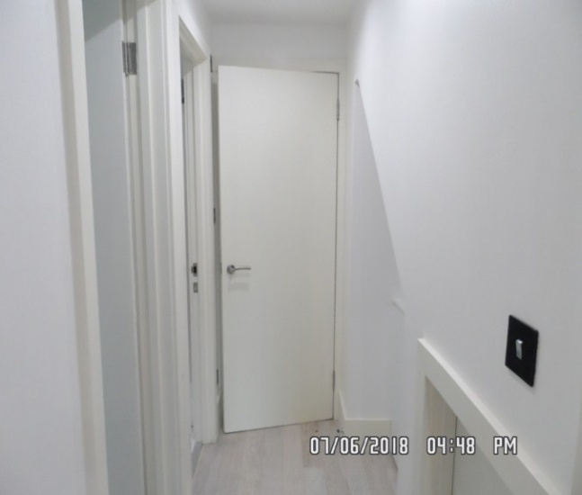 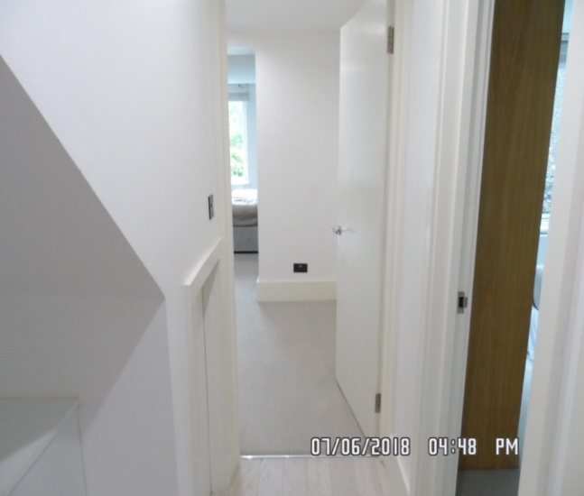

Smoke alarm Walls 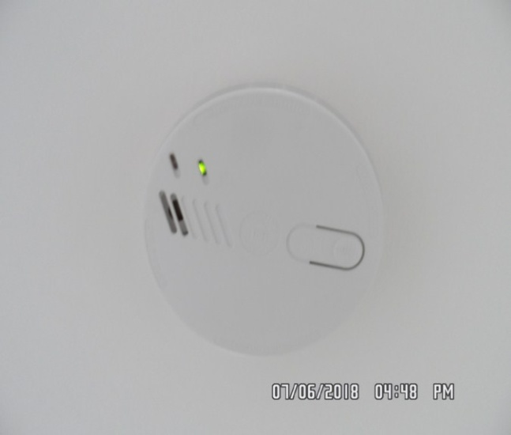 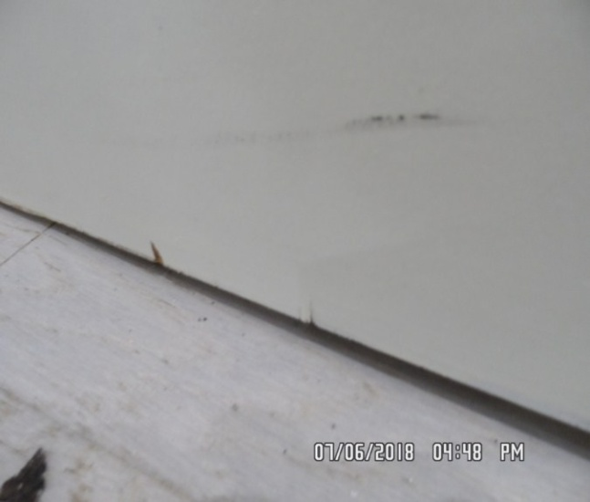

Cupboards Washer 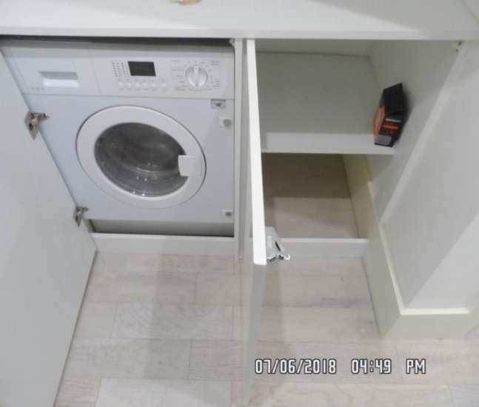 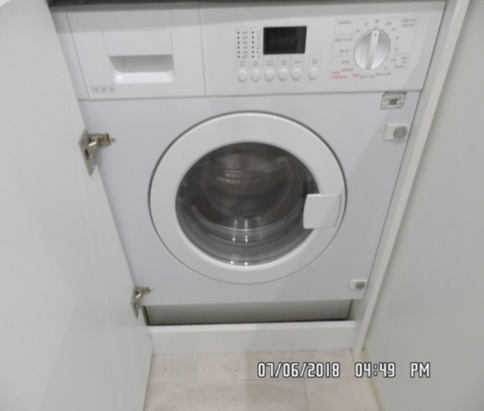

Washer Flooring 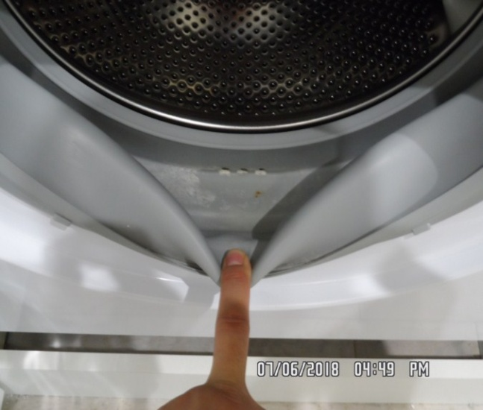 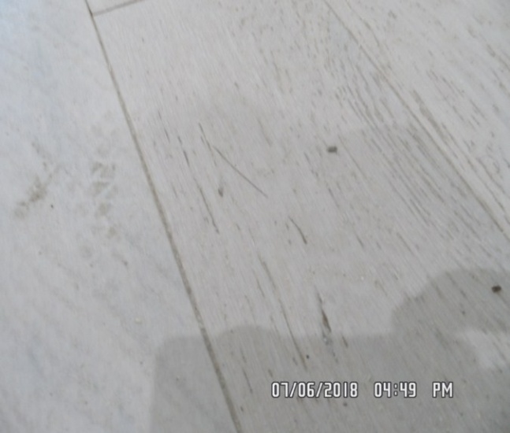

Cupboard Cupboard 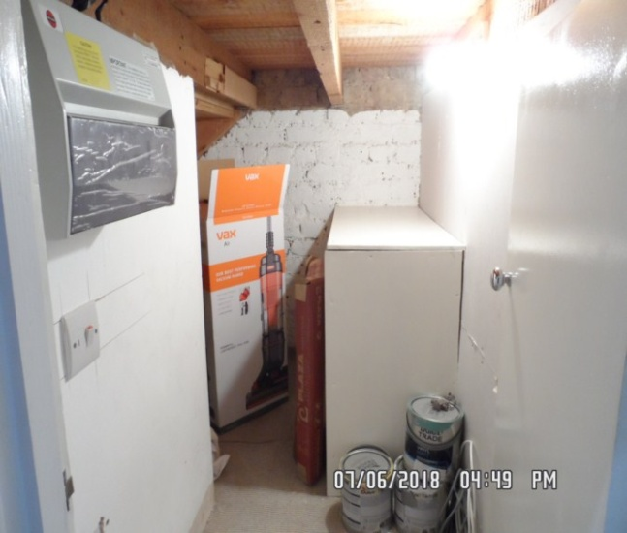 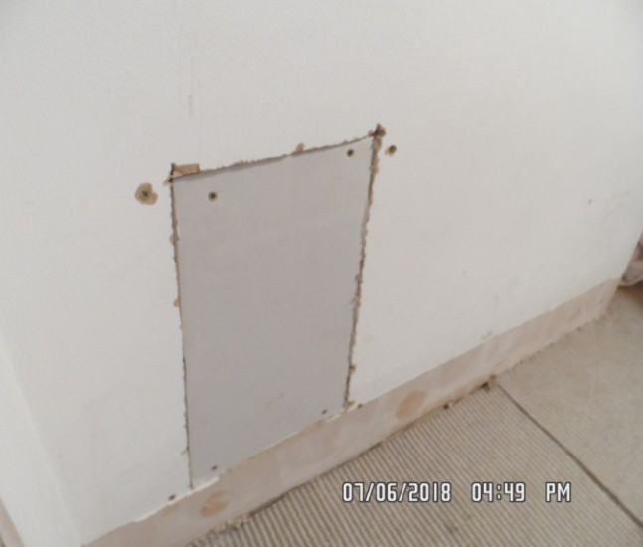

**BEDROOM 1**

|  |  |  |  |
| --- | --- | --- | --- |
| **Door** | Exterior Door Frame  Wood painted cream |  |  |
|  | Exterior Door  White wood with brushed metal handle | Small chip left hand side edge low level |  |
|  | Interior Door Frame | 1. 1 x circular stain from doorstop right hand side 2. Interior frame mid level 1 x chip seen at an angle |  |
|  | Interior Door  White wood with brushed metal handle |  |  |

**BEDROOM 1**

|  |  |  |  |
| --- | --- | --- | --- |
| **Walls** | Plaster painted white  Pale blue painted feature wall to right hand side in main area | 1. 2 x Nail holes to wall left of entry 2. Horizontal smudge marks to wall right of entry low level and 2 x Screws with surrounding chipping 3. Facing wall has 2 x Pinholes and 1 x Nail hole right of window 4. Nail hole to left wall above double switch 5. Grout of scuffs to left wall beneath sockets 6. Light signs of scuff marks seen at mid to low level in places 7. Slight chipping at an angle to the front facing wall at low level |  |
| **Ceiling** | White plaster | 1. Intermittent stress crack into edges |  |
| **Lights** | 6 x White metal spotlights | 1. All units tested and working |  |

**BEDROOM 1**

|  |  |  |  |
| --- | --- | --- | --- |
| **Woodwork** | Skirting painted cream | 1. Intermittent stress cracks to top edges 2. Some light scuffing to the skirting in places 3. Left hand side skirting some yellow staining seen to the top surface 4. Dust build-up seen in places throughout |  |
| **Windows** | White wood single glazed includes single opening casement  White wood sill  Chrome bar catch with 2 x White metal catchers  Plastic ventilation fan fitting to glass | 1. Paint work flaking at low level 2. Smudge to front edge of sill 3. Glass dirty to exterior |  |
| **Curtains** | White wood Venetian blind | 1. Pelmet currently missing 2. Blinds intact and in good order |  |

**BEDROOM 1**

|  |  |  |  |
| --- | --- | --- | --- |
| **Flooring** | Beige and cream striped | 1. 3 x Faint spot stains near en-suite entrance 2. Small assortment of furniture indentations 3. Faint brown smudge marks to edge of floor right of double main socket opposite entry 4. Grey spot mark to left of single wardrobe 5. Some light debris to the top surface |  |
| **Built in wardrobe** | Light wood includes double mirrored doors  3 x Narrow shelves  1 x Fitted shelf  Chrome hanging rail  LED strip light |  |  |
| **Single wardrobe** | Comprises single mirrored door with brushed metal handle  2 x Shelves  2 x Half width compartments  Chrome hanging rail |  |  |

**BEDROOM 1**

|  |  |  |  |
| --- | --- | --- | --- |
| **Side table** | Comprises chrome legs  Black wood frame | 1. Some light dust build-up to the top surface |  |
| **Angle poise lamps** | 2 x Light white and silver metal lamps | 1. Both tested and working for paper |  |
| **Dining chair** | Moulded plastic black wood and light wood legs | 1. Dust build-up to the top surface |  |
| **Bedside tables** | 2 x Black wood each with single drawer each drawer has chrome handle | 1. Some light dust build-up |  |
| **Bed** | King-size white and dark grey striped divan bed base  Matching mattress  Ripple effect dark grey leather style upholstered headboard | 1. Fire labels not visible 2. Unable to fully inspect currently fitted |  |

**BEDROOM 1**

|  |  |  |  |
| --- | --- | --- | --- |
| **Throw cushions** | 2 x Pale grey large with beige and yellow triangle pattern  1 x Dark grey suede effect |  |  |
| **Linen** | All white fabric  4 x Pillows  4 x Pillow cases  2 x King-size bed sheets  1 x King-size duvet |  |  |
| **Throw blanket** | 1 x King-size beige padded |  |  |
| **Doorstops** | 2 x Chrome doorstops with black rubber tips |  |  |

Bedroom 1 Bedroom 1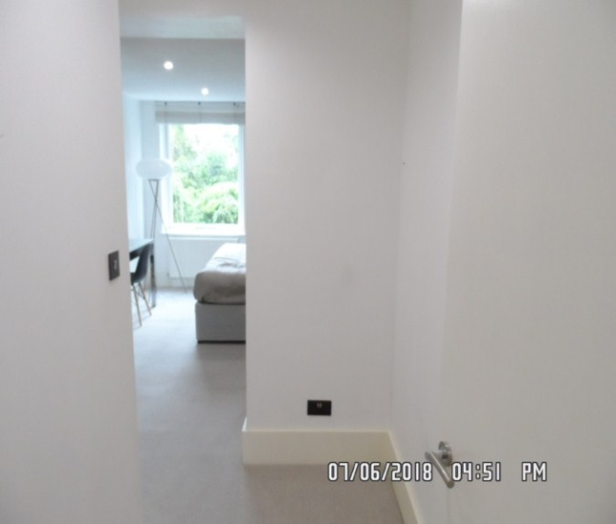 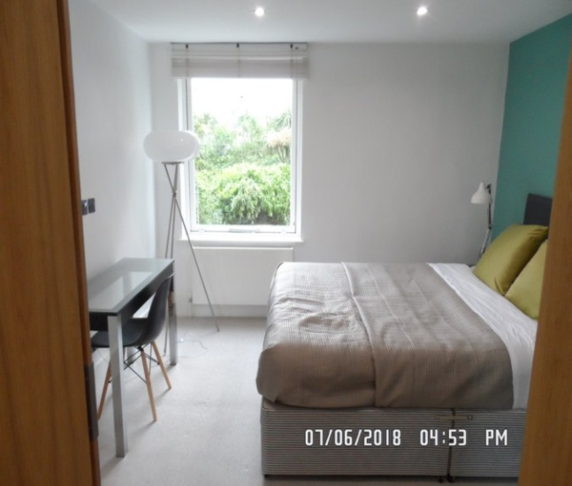

Bedroom 1 Window 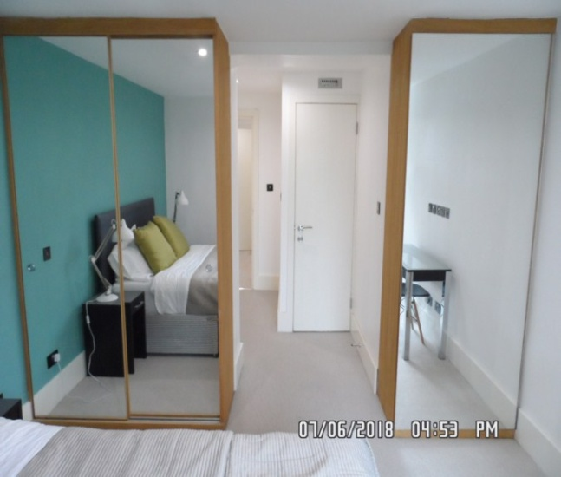 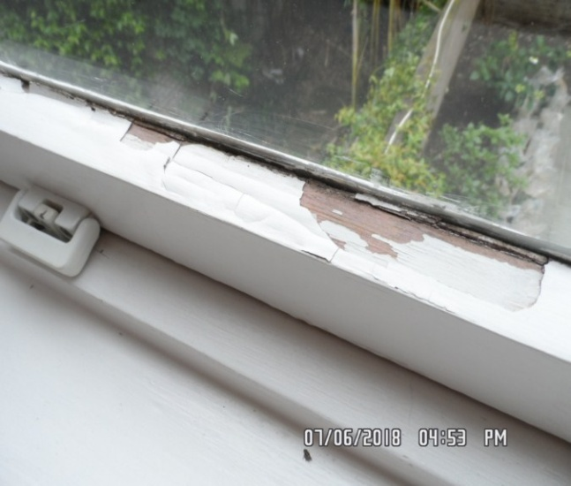

Skirting Flooring 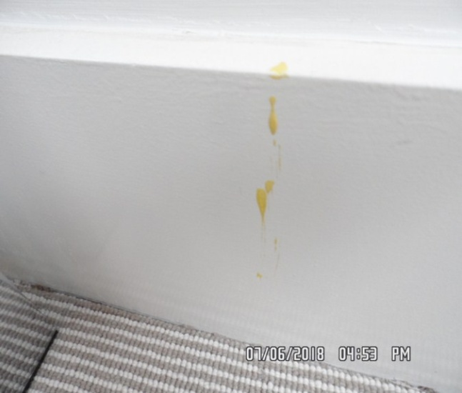 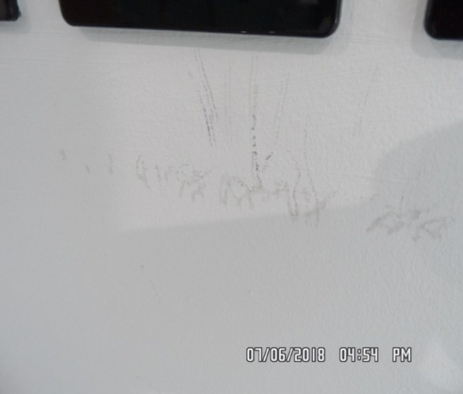

Wardrobe 1 Wardrobe 1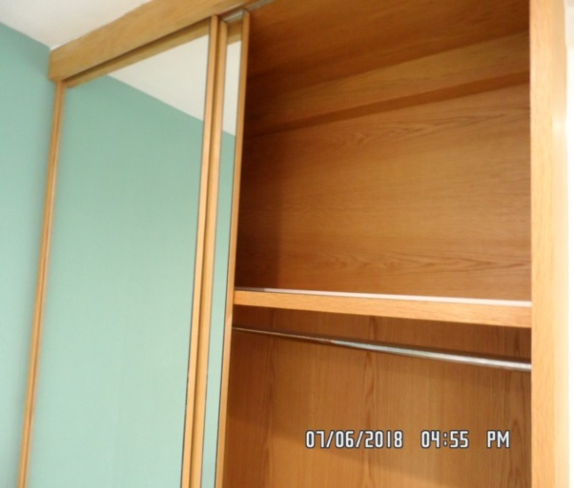 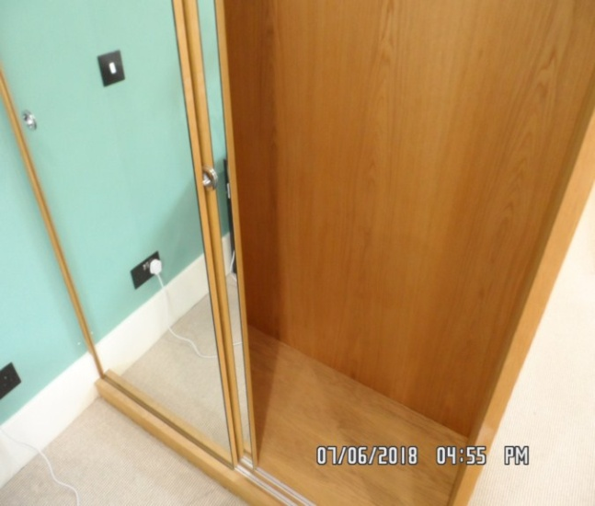

Wardrobe 2 Wardrobe 2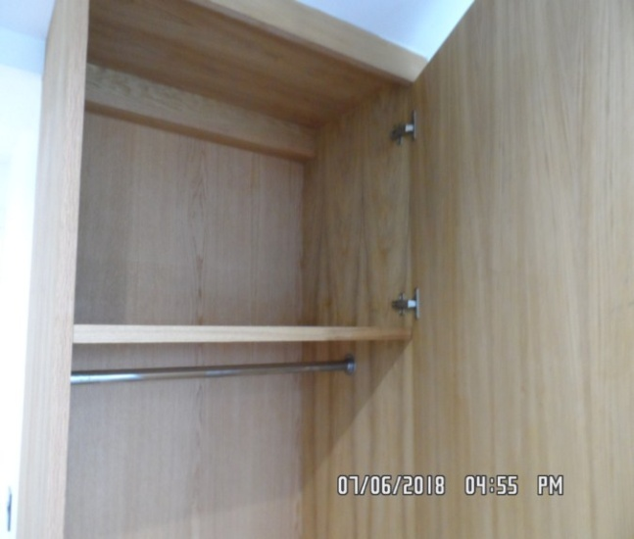 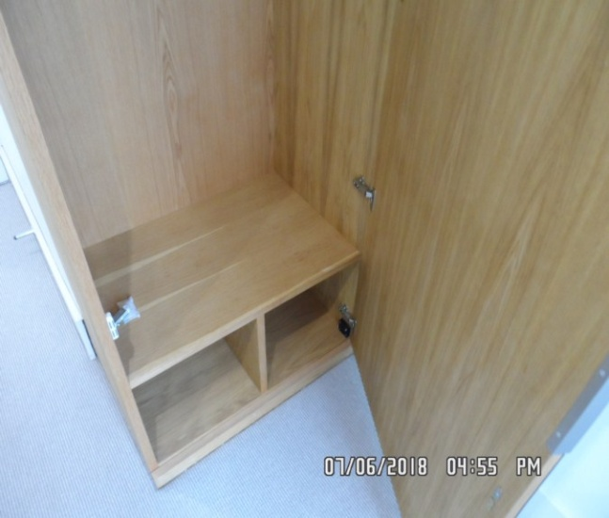

**ENSUITE BATHROOM**

|  |  |  |  |
| --- | --- | --- | --- |
| **Door** | Exterior Door Frame  White wood |  |  |
|  | Exterior Door  White wood with brushed metal handle |  |  |
|  | Interior Door  White wood with brushed metal handle  Brushed metal twist lock | 1. Some light drip marks and scuffing at mid to low level |  |
| **Walls** | White plaster  Frameless mirror  Clear glass shelf with dark grey mounting | 1. Mirror has large stain to bottom edge 2. Small number of minor marks mid to low level 3. Right hand side wall filled applied to the wall in the process of being painted 4. Tile sections all appear to be intact 5. 1 x drilled hole at high level 6. Appears to be for the showerhead |  |
| **Ceiling** | White plaster | 1. Appears to be intact and in good order |  |

**ENSUITE BATHROOM**

|  |  |  |  |
| --- | --- | --- | --- |
| **Lights** | 3 x White metal spotlights | 1. All tested and working |  |
| **Switches and sockets** | Black plastic shavers only sockets |  |  |
| **Flooring** | White gloss tiles with matching skirting | 1. Debris seen to the top surface 2. Could benefit from further cleaning 3. Light discolouration to grout throughout 4. Rear facing wall filler applied now painted 5. Skirting appears to have some applied to the right hand side |  |

**ENSUITE BATHROOM**

|  |  |  |  |
| --- | --- | --- | --- |
| **Radiator** | Chrome heated towel rail | 1. Intact and in good order 2. Could benefit from further cleaning |  |
| **Sink** | White acrylic with chrome mixer tap and plug  White acrylic unit comprises single drawer with chrome handle | 1. Tap tested for water pressure 2. Some light dust debris seen 3. Could benefit from final clean to interior |  |
| **Toilet** | White ceramic toilet with white plastic toilet seat and lid  Chrome double flush button | 1. Flush tested and working 2. Could benefit from full clean 3. Heavily discoloured to the interior |  |

**ENSUITE BATHROOM**

|  |  |  |  |
| --- | --- | --- | --- |
| **Shower cubicle** | White acrylic basin with clear glass shower screen door, chrome handle and chrome frame  Grey tiled walls  Chrome mixer tap  Handheld shower head  Flex hose and wall bracket | 1. Showerhead not currently in place 2. Integrated mixer tap in place –could benefit from final clean 3. Shower cubicle currently in process being refitted |  |
| **Toilet roll holder** | Chrome |  |  |
| **Miscellaneous** | Chrome toilet brush with matching holder | 1. Appears new |  |

En-suite En-suite

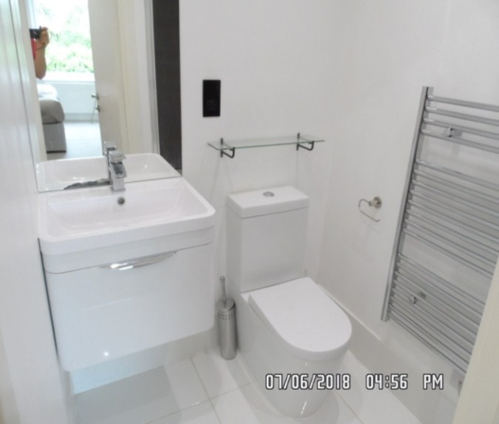 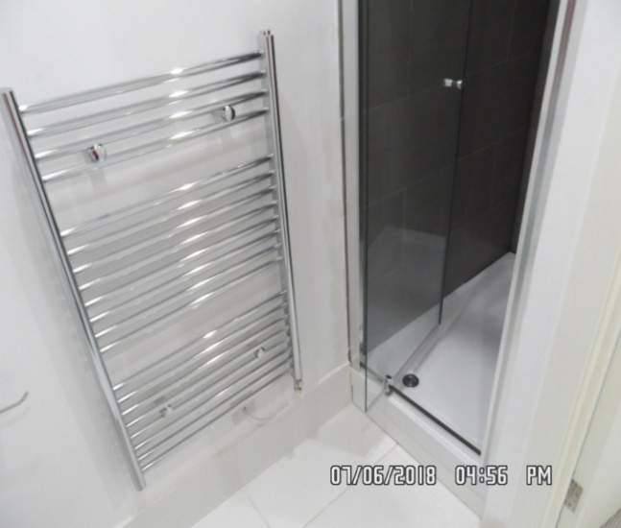

Basin Vanity drawer

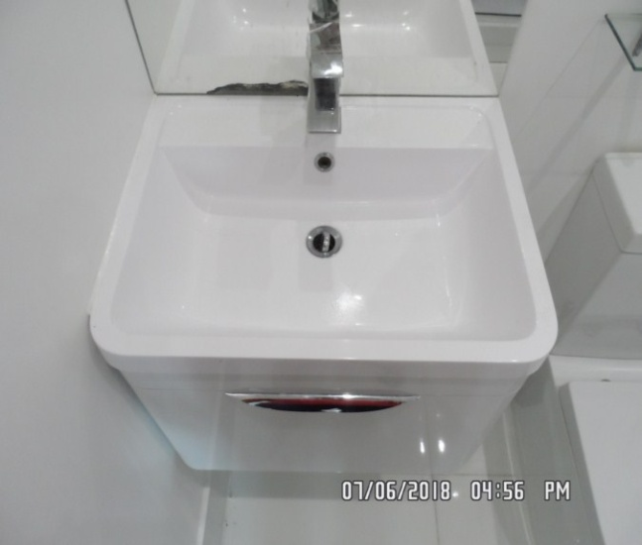 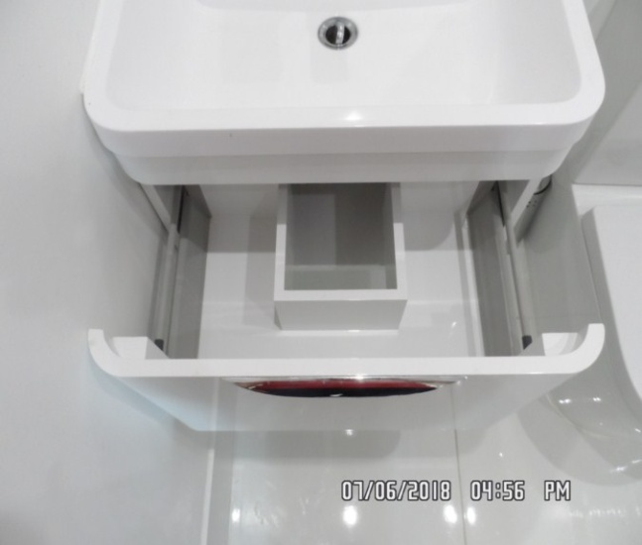

Toilet Shower

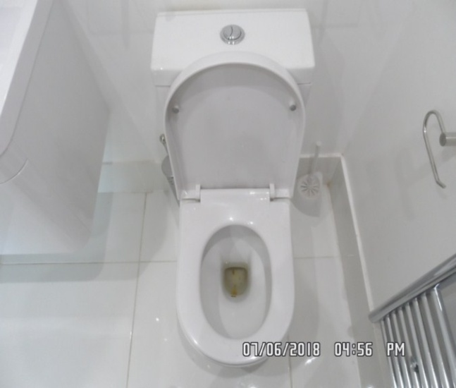 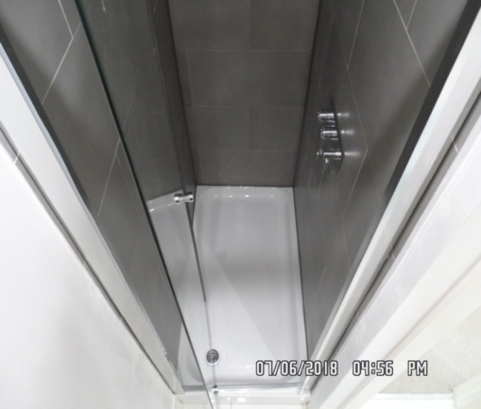

Shower Flooring

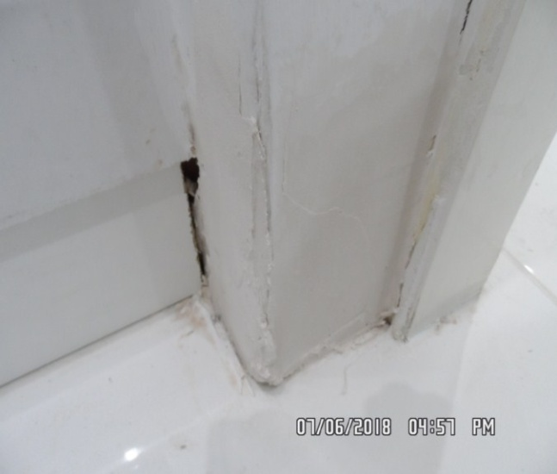 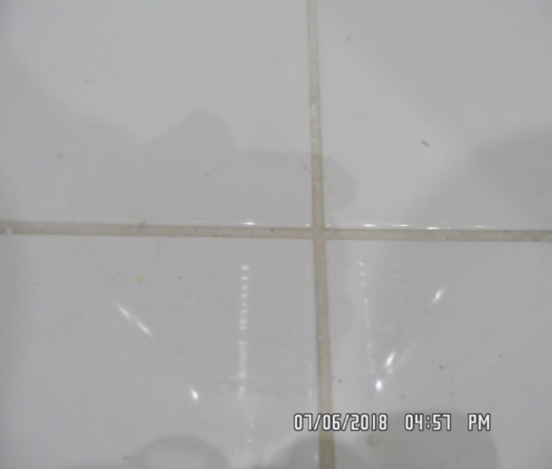

Mirror

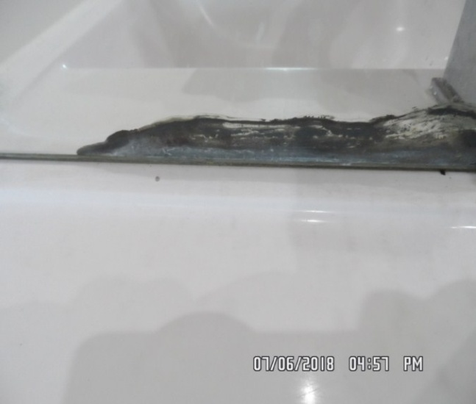

**BEDROOM 2**

|  |  |  |  |
| --- | --- | --- | --- |
| **Door** | Exterior Door Frame  White wood | 1. Intact |  |
|  | Exterior Door  White wood door with brushed metal handle | 1. Small brown smudge mark to handle 2. Intact |  |
|  | Interior Door Frame  White wood |  |  |
|  | Interior Door  White wood door with brushed metal handle | 1. Small brown smudge mark to handle |  |
| **Walls** | White plaster  Blue painted feature wall to facing wall | 1. 1 x Screw and 3 x Pin holes to right hand side wall 2. Front facing walls scratches to the blue paint, most notably to the far left hand side at mid level 3. Left hand side of window area at low level some light water damage seen 4. Some light hairline cracking seen |  |

**BEDROOM 2**

|  |  |  |  |
| --- | --- | --- | --- |
| **Ceiling** | White plaster | 1. Appears to be intact 2. Some scuffing seen to the crossbar |  |
| **Lights** | 4 x White metal spotlights | 1. All tested and working |  |
| **Woodwork** | Skirting painted cream | 1. Some light hairline cracking to the top surface 2. Some light very minor scuffing seen in places |  |
| **Windows** | White wood framed single glazed comprises opening casement  Matching sill  Casements has 2 x Chrome latches and 2 x White metal safety catchers | 1. Dusty to exterior 2. Light scuffing to frame and sill 3. Light cracking to sill |  |
| **Curtains** | White wood Venetian blind |  |  |

**BEDROOM 2**

|  |  |  |  |
| --- | --- | --- | --- |
| **Flooring** | Cream and beige striped carpet | 1. Furniture indentations to edges 2. 2 x Dark grey smudge marks by built in wardrobe 3. “V” shaped grey stain beneath radiator 4. Furniture indent marks to the top surface |  |
| **Radiator** | White metal radiator with thermostatic valve  Valve cap present |  |  |
| **Built in wardrobe** | Comprises 3 x Metal sliding doors with chrome handles  Left hand side compartment contains 8 x Smaller compartment  Middle compartment contains chrome hanging rail  Right hand side compartment contains chrome hanging rail and 2 x Smaller compartments  Unit also includes full width upper shelf |  |  |

**BEDROOM 2**

|  |  |  |  |
| --- | --- | --- | --- |
| **Dining chair** | Black moulded plastic with light wood legs |  |  |
| **Lamps** | 2 x White and silver metal Anglepoise lamps | 1. Bulb missing to 1 lamp |  |
| **Bedside tables** | 2 x White wood each includes drawer with chrome handle | 1. 1 x Unit has drawer handle loose 2. 2 x Circular stickers to front edge of top panel |  |
| **Bed** | Kingsize divan in white and dark grey striped fabric  Matching mattress  Grey rippled effect leather type upholstery headboard | 1. Fire labels not visible due to bedding |  |
| **Miscellaneous** | 1 x Yellow, blue and grey zigzag pattern |  |  |

**BEDROOM 2**

|  |  |  |  |
| --- | --- | --- | --- |
| **Linen** | 2 x King-size bed sheets  1 x King-size duvet  1 x King-size duvet cover  2 x Square pillows in white fabric  2 x Square pillow cases in white fabric  2 x Regular pillows in white fabric  2 x Regular pillow cases in white fabric  1 x King-size padded throw blanket in beige |  |  |
| **Doorstop** | Built-in chrome doorstop with black rubber tip |  |  |

Bedroom 2 Bedroom 2

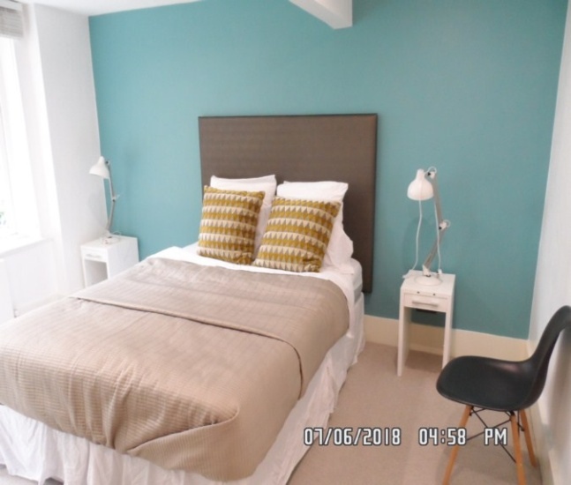 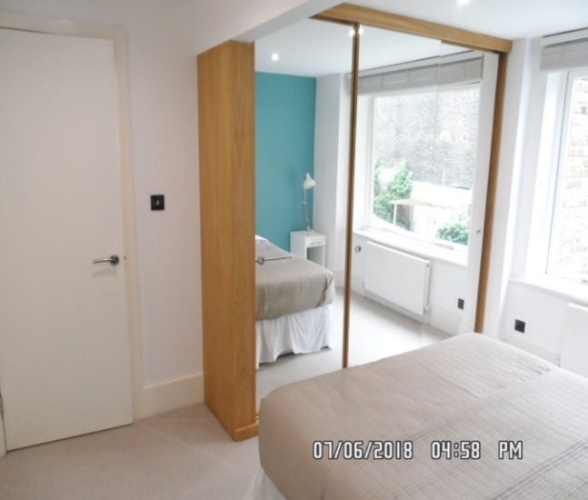

Bedroom 2 Wardrobe 1

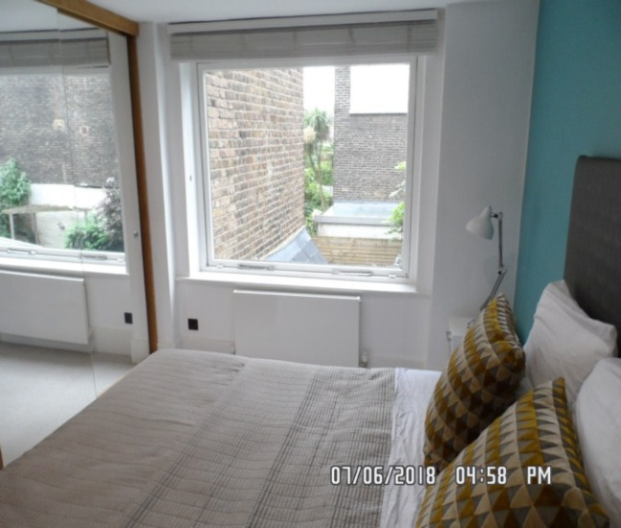 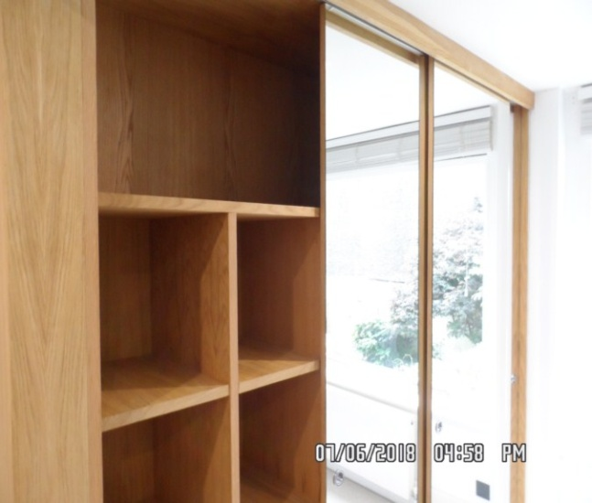

Wardrobe 1 Walls

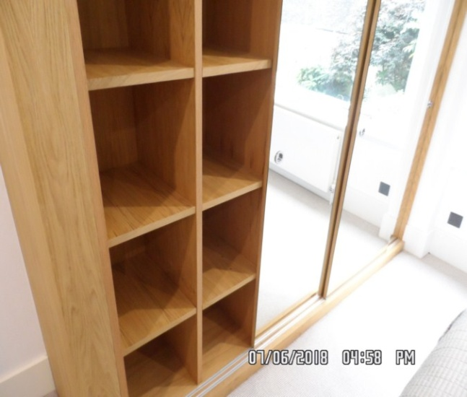 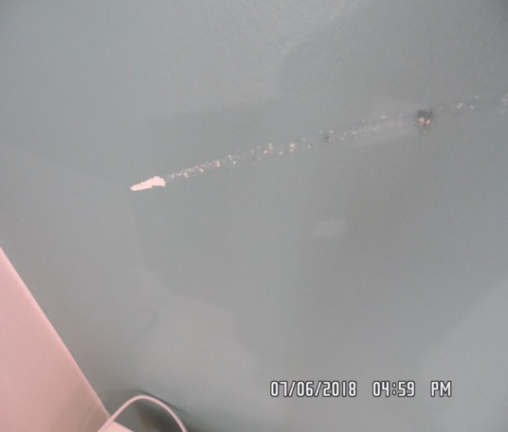

Wall/ window Window

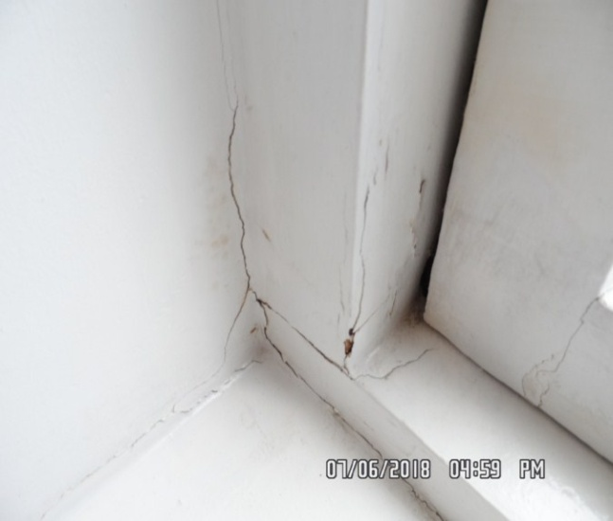 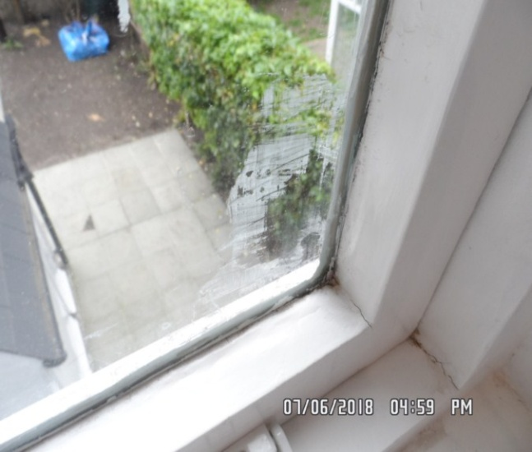

**BATHROOM**

|  |  |  |  |
| --- | --- | --- | --- |
| **Door** | Exterior Door Frame  White wood |  |  |
|  | Exterior Door  White wood with brushed metal handle |  |  |
|  | Interior Door Frame  White wood | 1. Appears to be intact and in good order |  |
|  | Interior Door  White wood with brushed metal handle  Brushed metal twist lock | Door interior twist lock very stiff  Small mark low level |  |

**BATHROOM**

|  |  |  |  |
| --- | --- | --- | --- |
| **Walls** | White plaster  Pale grey  Splash back tiles   1. x Frameless mirror | 1. 3 x Nails to left wall above bath 2. Small number of light scuffs mid to low level |  |
| **Ceiling** | White plaster | 1. Some patchy paintwork seen near extractor fan |  |
| **Lights** | 3 x White metal spotlights | 1. All tested and working |  |
| **Windows** | White wood framed with frosted single glazed glass  Grey gloss sill | 1. Mottling and cracking to surface of sill on the gloss 2. Light dirt to window frame 3. Window sill peeling to the underside of the glass panel 4. Frame appears to have some flaking to paint in places |  |
| **Curtains** | White wood Venetian blind | 1. Intact |  |

**BATHROOM**

|  |  |  |  |
| --- | --- | --- | --- |
| **Flooring** | White gloss tiles with matching skirting tiles | 1. Vacuumed for the start of tenancy 2. Some light discolouration seen to grout |  |
| **Radiator** | Chrome heated towel rails | 1. Intact |  |
| **Sink** | White ceramic with chrome mixer tap and plug  Under sink unit white lacquered wood comprises drawer with chrome handle | 1. Tap and plug tested and working 2. Some light tarnishing to popup plug 3. Drawer in good clean order |  |
| **Toilet** | White ceramic toilet with white plastic toilet seat and lid  Chrome double flush button | 1. Flush tested and working |  |

**BATHROOM**

|  |  |  |  |
| --- | --- | --- | --- |
| **Bath unit** | White acrylic with white wood side panel  LED strip light to floor level  Chrome mixer tap  Waste, flex hose, wall bracket and handheld shower head | 1. Intact and good clean order throughout |  |
| **Shower cubicle** | Comprises white acrylic basin  Grey gloss fixed screen with chrome frame  Clear glass sliding door with chrome handle  Chrome fixed shower head  Chrome handheld shower head with matching flex hose, wall bracket and mixer tap | 1. Clean to interior throughout |  |
| **Toilet roll holder** | Chrome | 1. Intact |  |
| **Toilet brush** | 1 x White plastic with matching holder | 1. Intact |  |
| **Extractor fan** | White plastic Manrose | 1. Tested and working |  |
| **Doorstop** | Chrome with black rubber tip |  |  |

Bathroom Bathroom

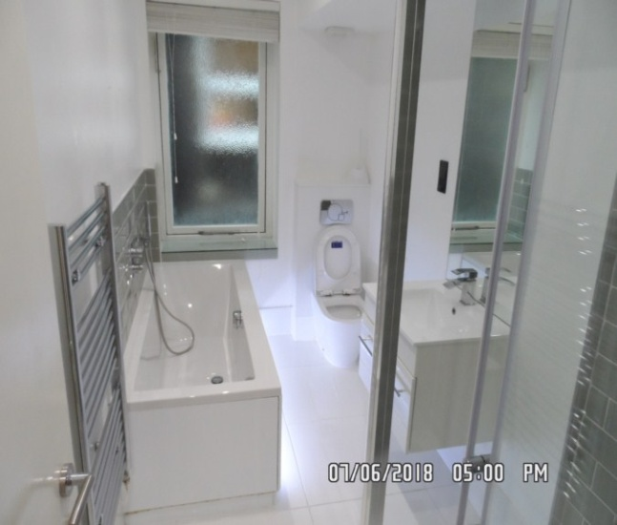 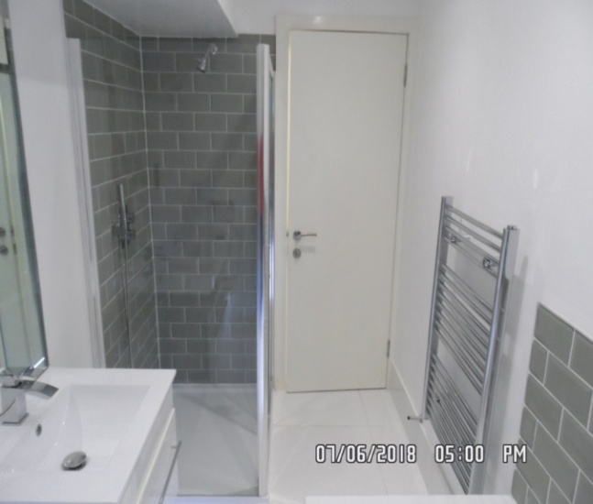

Bath Bath

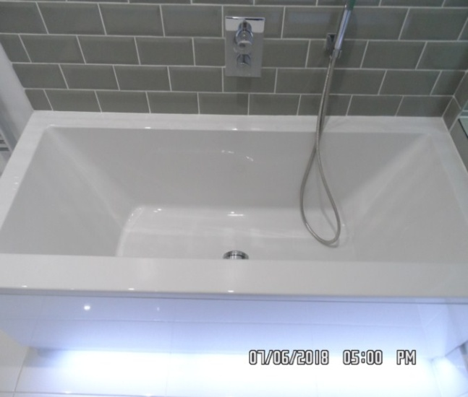 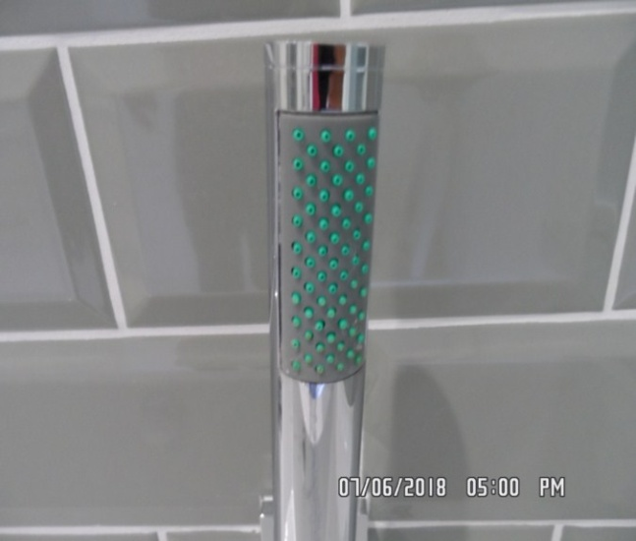

Toilet Basin/vanity drawer

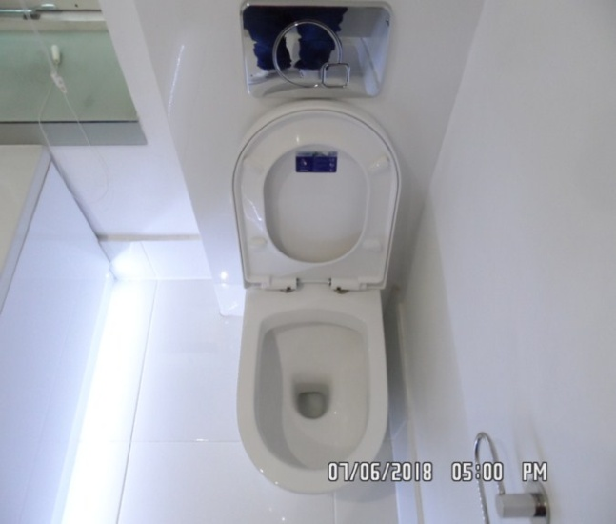 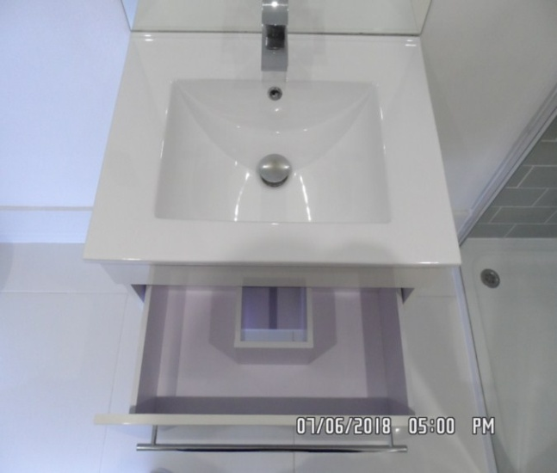

Shower Shower

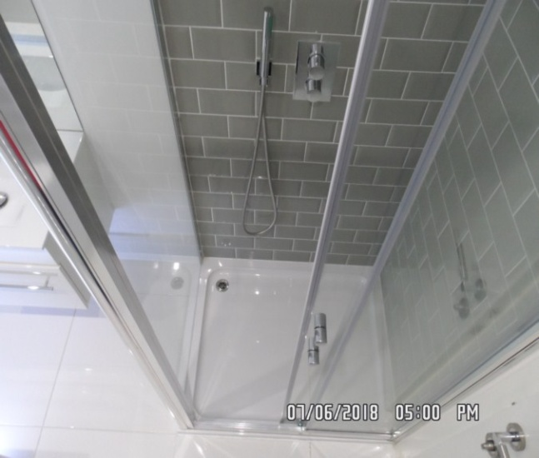 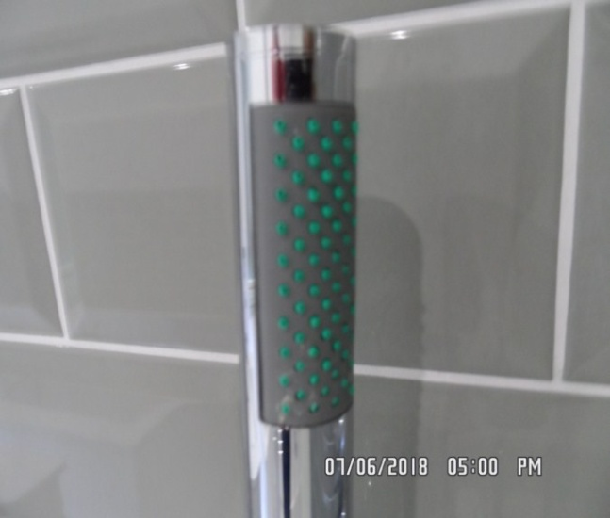

Shower Window sill

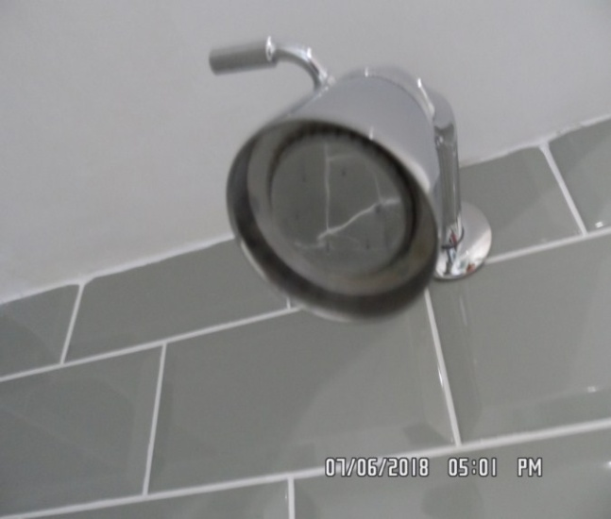 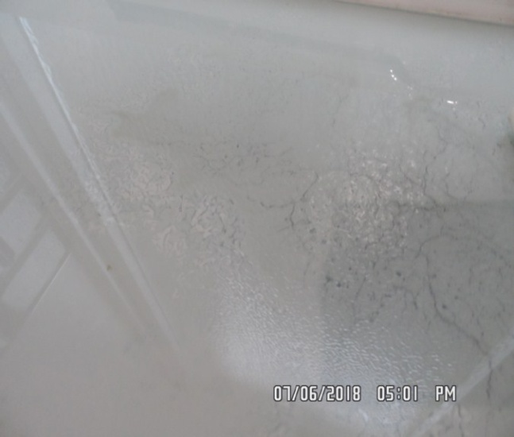

Window

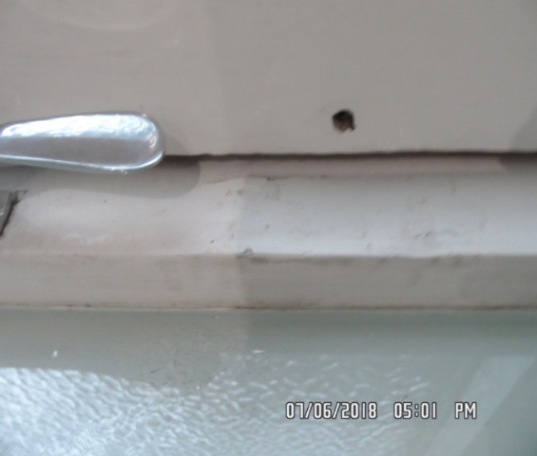

# DECLARATION AT CHECK IN

This inventory has been examined and, subject to marginal comments found to be correct.

## On behalf of the landlord

on behalf of the tenant \_\_\_\_\_

commencement of tenancy **\_\_\_\_\_\_**

## **N.B**

This inventory is correct to the best of our knowledge but advise you to examine its contents prior to signing, as we can not be held responsible for any errors or omissions. Descriptions are for identification purposes only.

The relevant utility companies must check all meter readings, as we can not be held responsible for any discrepancies

**Please ensure that all items listed in this inventory are in the same location at the end of the tenancy.**

**ADDITIONAL AMENDMENTS**

|  |  |  |
| --- | --- | --- |
| DATE | DESCRIPTION OF CHANGES | AGENTS/LANDLORD SIGNATURE |
|  |  |  |
|  |  |  |
|  |  |  |
|  |  |  |
|  |  |  |
|  |  |  |
|  |  |  |
|  |  |  |
|  |  |  |

WHEN ADDITIONS/AMENDMENTS ARE MADE BY THE LANDLORD, TENANT OR AGENT THE RELATIVE PARTIES MUST BE INFORMED

**GENERAL COMMENT**

It should be noted that it is not the responsibility of the Inventory Clerk to open, unpack, empty or itemise items stored in carrier bags

or other containers unless it is made specifically clear they are the property of the Landlord.

**

   